**APL405 (Machine Learning in Mechanics) | Lab – 7 |**

**Physics Informed Neural Network**

**Assignment**

1. Solve an Inverse problem (Data driven Identification): A 1-dimensional bar is clamped on both ends. The governing equation is represented by,

$$\frac{d}{dx}\left(EA\frac{du}{dx}\right)+p=0$$

$Ω=[0, 1]$ is the domain with, ${ Γ}_{D}=\left\{x\right| x=0, x=1\}$, ${ Γ}_{N}=∅$. The deflection over the whole domain is known and given by,

$$u(x)=sin⁡(2πx)$$

The distributed load over the whole domain can be given by,

$$p\left(x\right)=-2\left(3x^{2}-2x\right)πcos\left(2πx\right)+4\left(x^{3}-x^{2}+1\right)π^{2}sin\left(2πx\right)$$

Using a Neural Network find the stiffness coefficient $EA(x)$ at 100 points uniformly distributed over the whole domain and plot $EA(x)$ vs $x$. Also plot the cost function history with epochs as shown in the class.

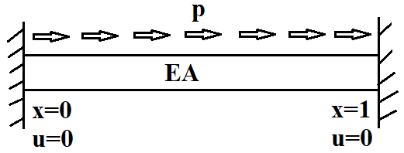

Note: The neural network will have two inputs $x$ and $u$. Output will be $EA(x)$. Also, the boundary conditions have no influence over the learning of model parameters.

1. Change the forward problem code shown in the class for a tapered bar problem with Neumann Boundary condition:

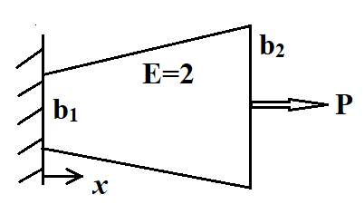

Breadth of the bar at clamped end $b_{1}=1$ and breadth at the free end is $b_{2}=2$. The length(*L*) and the width(*t*) are both 1 (unity). Young’s modulus E is 2 units. The concentrated point load at the free end $P=10$ units. Predict the displacement $u(x)$ over 50 points uniformly distributed over the domain $Ω=[0, 1]$. Plot $u(x)$ vs $x$ and cost history (total cost, boundary condition loss, Neumann condition loss and differential equation loss) vs epochs.

Note: Neumann condition is given in case of a bar problem as $EA\frac{du}{dx}|_{x=1}=P$.

1. Predict the vertical displacement (*y*) in case of a Euler-Bernoulli beam.The governing equation is represented by,

$$\frac{d^{2}}{dx^{2}}\left(EI\frac{d^{2}y}{dx^{2}}\right)=-q$$

A clamped-clamped boundary condition can be stated as,

$y(x=0)=0$, $y(x=L)=0$, $\frac{dy}{dx}(x=0)=0$, $\frac{dy}{dx}(x=L)=0$.

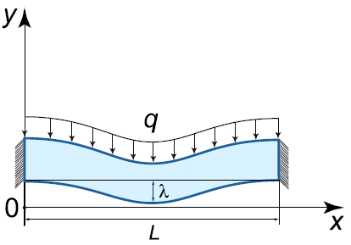

Assume *L*, *E*, *I* and *q* as 1(unity). Through the prediction of a neural network, plot y at 100 sample points in the domain. Also plot cost function history for different losses (total, boundary and differential equation loss).